From: https://medium.com/@andersentda/putins-philosophers-hint-at-why-he-invaded-ukraine-and-what-may-be-coming-next-ffa683d66d6c
By: Tim Anderson, PhD

Putin’s philosophers hint at why he invaded Ukraine and what may be coming next

From Ivan Ilyin to Aleksandr Dugin, these philosophers have Putin’s ear
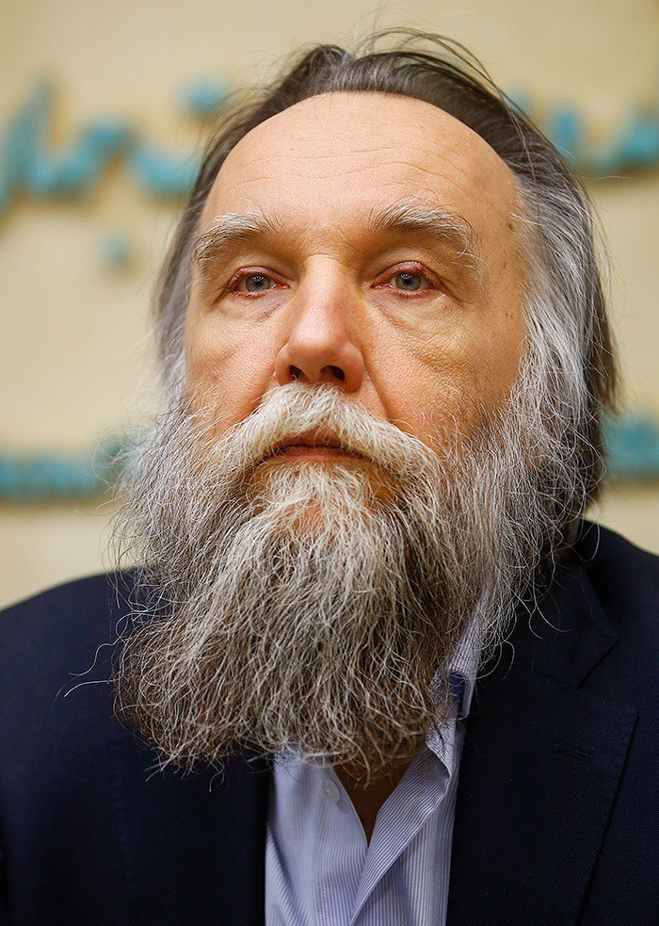
Alekandr Dugin in 2018. Wikimedia Commons.
Jordan Peterson recently suggested that the war in Ukraine is a “civil war” between Western powers. That is an odd use of the term civil war, but Peterson may be having more insight into the Russian mindset than the rest of us, because, for them, the war in Ukraine is a war over what set of ideals dominate in Europe and Asia, Anglo-American liberalism or Russian traditionalism.
It is Athens versus Sparta. Carthage versus Rome. And the consequences go far beyond regional domination.
In 1917, at the height of trench warfare during the Great War, a civil war broke out in Russia. The two combatants were known by their colors: red and white.
- The reds were the Bolsheviks, followers of Marx’s communism, led by Lenin and Trotsky.
- The Whites were the anti-Bolsheviks, the pro-Tsarists.
The civil war raged for five years but, even with France and Britain committing troops in support of the White Army, the Red Army prevailed.
The rest is history. The Soviet Union with all its corruption and terror grew out of the ashes of Imperial Russia and the Whites were exiles.
Despite western support for the Whites, however, their support for the Tsars should tell you that they were hardly friends of Western Democracy. They simply represented a different vision for Russia, no less authoritarian than the Bolsheviks.
Indeed, one of their main philosophers, Ivan Ilyin, who died in exile in 1954, argued that Russia had a duty to protect traditional autocratic rule, in opposition to Western liberalism.
Although Ilyin initially supported Hitler’s fascist regime and its opposition to Bolshevism, he was never a fascist and certainly did not support what Nazism came to be. His position was rather that of a monarchist, who saw the Monarch as the pater familias of the Nation.
It is no surprise that Putin admires Ilyin’s work, even having his remains repatriated to Russia.
What, therefore, is Putin if not the re-emergence of Tsarist Russia? The White Army is victorious over the Red, after 75 years of exile, with Putin as the new Tsar.
It turns out to be a bit more complicated than that.
While Putin admires Ilyin, Putin’s decision making has been more closely linked with the work of another philosopher, ultra-nationalist Aleksandr Dugin.
Dugin, a lunatic fringe thinker during the Soviet era, is a towering force in Russian elite thinking promoting Russia as a counter-balance to western culture. Traditionalist, anti-American, and anti-Semitic, Dugin sees Russia as having a manifest destiny in Eurasia, with a duty to push out “Atlanticism” — a word meaning basically everything Western Europe and America stand for, liberalism, free markets, globalization, cultural homogenization, and democracy.
Dugin’s view is that Russia represents empire, Rome, while the United States and its allies represent mercantilism and plutocracy. He compares those who won the Cold War to ancient Carthage, which Rome defeated in the Punic wars and utterly destroyed.
Carthage was a powerful and wealthy empire based on trade, an aristocracy with little regard for the poor, who worshiped Moloch, the bloodthirsty god of wealth to whom one sacrificed babies and young children. Thus, with the fall of the Soviet Union, he says, Carthage, or what he thinks Carthage represented, had its revenge.
Indeed, Dugin, in a 1997 book, The Foundations of Geopolitics: The Geopolitical Future of Russia, argued that, in order to reassert its power on the world stage, Russia needed to “destabilise internal political processes in the US”, encourage Britain to leave the EU, and annex Ukraine.
Clearly, Putin has been paying attention.
Some have called Dugin “Putin’s brain” or “Putin’s Rasputin” although he has no direct ties to the Kremlin. That is an overstatement.
Putin has, like many politicians, followed a much more meandering course as he has navigated various internal and external crises and pursued different policies. His invasions of his neighbors as well as his interference in US and other elections certainly aligns with Dugin’s thinking, but in many other ways Putin has plotted a course to make Russia an equal or even lower ranking member of various regional axes, rather than a dominant power.
While Putin may outwardly support Russian exceptionalism, he is no dummy. He knows his nation is in no position to build an empire and, in terms of economic power, is more a heavily nuclear armed Canada than a new Rome.
Dugin has been disappointed in Putin for failing to achieve the Eurasian vision he laid out over the past 20 years but also willing to forgive him, believing that Putin is Russia’s best hope to keep its politics pure of liberalism and that Eurasianism is inevitable.
Dugin’s work is remarkable because it is so well-known in Russia but outside of it no one seems aware of quite how influential it is. It forms a plan to create a Moscow centered Empire in Eurasia with numerous allies and satellite states as well as reform world politics in Russia’s favor.
While its conclusions are clearly deranged and vastly overestimate Russian capabilities in affecting world politics, Dugin has had considerable influence over Russian nationalists.
The book explains how Russia can regain influence in the world through disruption, alliances, and annexations. It contains recipes for how to deal with almost every region in the world.
For example, it recommends forming a Moscow-Berlin axis in which Germany is encouraged to dominate Central and Eastern Europe. This is not a new idea of course. Kaiser Wilhelm certainly hoped to create such an axis with Tsar Nicholas II to counter-balance Anglo-French aggression, going by the so-called Willy-Nicky letters between them. Ultimately, however, he ended up pushing Russia into the arms of the Allies with his own visions of world dominion.
France, meanwhile, is expected to go with Germany to form a European bloc, which seems like a rather serious misunderstanding of Franco-German relations.
Meanwhile,
- numerous nations are to be absorbed into the new Russian empire such as Finland, Belarus, and Moldova.
- Other nations such as Poland, Latvia, and Lithuania were to be given special status, to be absorbed later.
Alliances with Islamic states were intended to also counter-balance Anglo-American interests, with a Moscow-Tehran axis also deemed important. (This is clearly working better for Putin than the Moscow-Berlin axis though maybe not as well for Iran.) Some central Asian nations were to be split between Russia and Iran such as Azerbaijan. Even a Moscow-Tokyo axis is suggested.
Ukraine meanwhile, Dugin asserts, has no right to exist at all. He says,
Ukraine as a state has no geopolitical meaning, no particular cultural import or universal significance, no geographic uniqueness, no ethnic exclusiveness, its certain territorial ambitions represents an enormous danger for all of Eurasia and, without resolving the Ukrainian problem, it is in general senseless to speak about continental politics
This has become a Putin talking point and clearly Dugin has called out Ukrainian independence as a major concern for any of Putin’s grandiose visions to succeed.
In some areas Putin clearly has been wiser than Dugin. Dugin, for example, suggests that China be dismantled. Putin has done the opposite and become closely allied with the Chinese Communist Party. Given that China is vastly more economically and militarily powerful now than in 1997, this is probably a necessary course correction.
Dugin views the UK, meanwhile, as an arm of Atlanticism and the United States and so must be cut off from Europe, as it has been with Brexit. Obsessed with ancient empires, Dugin sees the USA and UK as the center of an Anglo-Saxon empire which must be figuratively pushed into the Atlantic.
Encouraging racial tensions and right wing isolationist policies in the USA is a top priority. We can see how this has succeeded to some extent with Trump only to backfire with Trump’s loss in 2020. Will a Republican Congress or the next Republican President play into Dugin’s hands? That remains to be seen.
I cannot overstate how dangerous Dugin’s ideas are. While Ilyin can be considered a mere Christian monarchist, Dugin’s Eurasianism is a call for violent conquest of two continents with the supposed goal of overthrowing American hegemony. He advocates no less than a kind of Russian Reich where all of Eurasia comes under Russian dominance. Such ideas are certainly familiar from the early 20th century, and he has found his Hitler in Putin. Whether Putin chooses to be that Hitler remains to seen.
Dugin’s ideas are not only dangerous but wrong. There is a reason why liberal democracies like the United States are hegemonic. Liberal nations, which Dugin considers so decadent, plutocratic, and libertine, have since the end of World War 2 been far more effective at forming close political and economic alliances than totalitarian nations like Russia and China. NATO may sometimes fail to get along but in terms of sheer military might it dwarfs both nations and will continue to do so.
The fact is that totalitarian nations do not make good allies. They are unstable and fickle.
Russia is unlikely to be able to form the kinds of alliances that Dugin envisions, nor does it have the economic and military might to absorb so many nations. It is all wishful thinking. Russia is a weak power with numerous internal problems, going from one crisis to another, and trying to counter what it sees as encroaching Westernization.
Over the past 25 years, Russia has attempted to form alliances with a rogue’s gallery of nations such as Iran, Libya, Iraq, North Korea, and Cuba who are hostile to the United States. In addition, it has formed alliances with India and China, both of which seek their own form of regional dominance, engendering a kind of strategic triangle rather than a Russian-led Eurasian bloc. Russia has ended up adding arms deals to these, trading advanced weaponry in an attempt to counter balance American interests. Nevertheless, both China and India trade far more with the United States.
These are not the actions of a powerful, continent-spanning empire, a new Rome. Rather they are the actions of a weak nation that cannot withstand American hegemony without strategic alliances with nations that are far more populous and economically rising.
One of the more dangerous ideas in Dugin’s philosophy that he believes in the formation of clusters of anti-American states in Eurasia, all armed with nuclear weapons from Russia. These “powerful, independent, nuclear empires” while dangerous to the world, including Russia, as Dugin acknowledges, are necessary to challenge American hegemony, which he believes benefits the most from non-proliferation since American conventional weaponry is so superior to that of other nations.
Dugin’s stance on nuclear weapons is tied to his empire building. That is, nuclear weapons are a strategic hedge against the expansion of Atlanticism. He seems uninterested in actually using them to achieve any aim. He has never advocated a preemptive strike and cautioned against direct confrontation with the USA. This is not surprising since so much of his philosophy rests on diplomacy and alliance building. That said, his advocating for the dismantling of sovereign nations seems to require some kind of violence. And in the case of China and India, both nuclear armed, some kind of nuclear confrontation would surely result.
Meanwhile, much of Putin’s willingness to use nuclear weapons in Ukraine rests on his desire to maintain his existing alliances. He will not trade all his strategic power for a tactical advantage. Nevertheless, he has bought into some form of Russian manifest destiny, and even if he pulls out of Ukraine and admits failure, he will not let go. Like Dugin, Putin believes that American influence cannot be allowed to exist on his borders.
How NATO and the West deal with the situation is complex because on the one hand militarily and economically the advantage is clear, but strategically there is a need to take Russian concerns seriously if not their lunatic visions of global dominance. Even if Putin keeled over tomorrow, Russian nationalists and hardliners would remain and many of the liberal minded Russians are long gone.
The idea that American power requires Russian weakness and vice versa is ingrained in the Russian psyche, even if Americans think little of such things. While expanding NATO may seem like a good idea from the perspective of protecting vulnerable nations friendly towards the West, from a global strategic point of view it is folly since it potentially leads us into a pre-World War I-esque set up for a major conflict. Thus, while NATO needs to supply Ukraine with what it needs to survive and escalate supplies and air defenses, it should take seriously Russian demands that it not expand towards Russian borders.
Dugin, Alexander. Last war of the World-Island: the Geopolitics of contemporary Russia. Arktos, 2015.
Dunlop, John B. “Aleksandr Dugin’s foundations of geopolitics.” Demokratizatsiya 12.1 (2004): 41–58.
Dugin, Alexander. Eurasian Mission: An Introduction to Neo-Eurasianism. Arktos, 2014.
405
10

